About RazorClean Security Services   Read Our Bios >

Personal security services are paramount in the current economic and political climate and RazorClean Security Services. has constantly remained one of the nation’s leading full-service security companies. We offer a variety of professionally, skillfully and discreetly managed programs and services for individuals, companies, facilities, organizations and governmental offices. No entity is too small, and we are happy to provide quotes for a variety of security needs for any size organization.

We pride ourselves on constantly expanding our knowledge, our education and our areas of expertise in all areas of security. We’re dedicated to remaining at the top of our field, and we’ve been able to develop, improve and expand our level and types of services to meet the needs and demands of our ever-increasing and discerning client base.

All of our comprehensive personal security service programs provide our clients with the finest benefits, support staff, experience, data and up-to-date information available. Whether security needs range from one officer to a full security department, we’ll evaluate the entire situation, help tailor a specialized program, and provide the skilled personnel to complete the assignment professionally, efficiently and cost-effectively. It just takes one quick call to RazorClean Security Services to begin the process.

[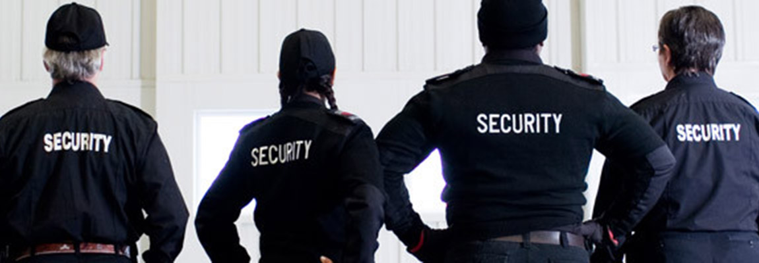](https://www.google.com/url?sa=i&rct=j&q=&esrc=s&source=images&cd=&cad=rja&uact=8&ved=0ahUKEwiAt7PclvHTAhWBSiYKHU5jD-cQjRwIBw&url=http://meawaysecurityservices.com/&psig=AFQjCNHG3I7OMplbWtTcOayjyyOl9Lq_cQ&ust=1494911193376032)

RazorClean Security Services is a full-service security firm backed by an executive team with unparalleled integrity and credentials, our team protects clients, residential and commercial buildings, hotels, schools, retail stores, hospitals and construction sites in the tri-state area. Additionally, high profile dignitaries and celebrities also seek RazorClean Security Services for protection because of our experienced staff and unwavering commitment to quality and customized needs.

[](https://www.google.com/url?sa=i&rct=j&q=&esrc=s&source=images&cd=&cad=rja&uact=8&ved=0ahUKEwiGy9mQiPHTAhUhxlQKHVOZAKQQjRwIBw&url=http://tmlevents.com/&psig=AFQjCNFpL-PKCQLgvUpZedJPpqdAKE-SxQ&ust=1494908914254742)[](https://www.google.com/url?sa=i&rct=j&q=&esrc=s&source=images&cd=&cad=rja&uact=8&ved=0ahUKEwjGytOiiPHTAhUow1QKHaFvAKoQjRwIBw&url=http://www.blueevents-agency.com/portfolio/events/?lang%3Den&psig=AFQjCNFpL-PKCQLgvUpZedJPpqdAKE-SxQ&ust=1494908914254742)[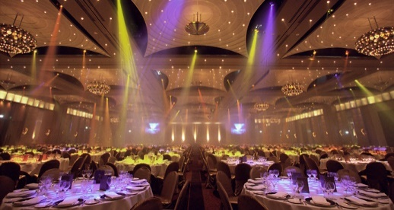](https://www.google.com/url?sa=i&rct=j&q=&esrc=s&source=images&cd=&cad=rja&uact=8&ved=0ahUKEwiy6fjwiPHTAhWM4iYKHQnSBwgQjRwIBw&url=http://sparknfizz.com/&psig=AFQjCNFpL-PKCQLgvUpZedJPpqdAKE-SxQ&ust=1494908914254742)[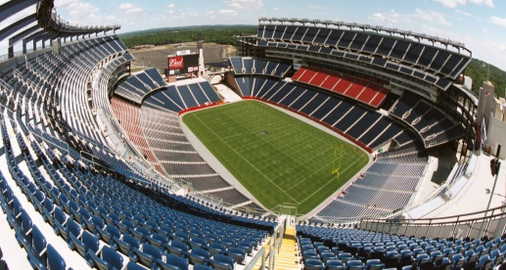](https://www.google.com/url?sa=i&rct=j&q=&esrc=s&source=images&cd=&cad=rja&uact=8&ved=0ahUKEwjp7vWWivHTAhUKQiYKHcs3AZwQjRwIBw&url=https://www.husseyseating.com/stadiums/&psig=AFQjCNFUkVyLH3Cccid3wGRFxtFPjTTANA&ust=1494909470131040)

Unlike many established firms, we ensure that as we continue to grow, we have a quality control task force to ensure each client's needs are met and exceeded. We forge solid relationships through our professional attention to detail, comprehensive services, vast security and legal expertise and pride in our work.

Clients greatly appreciate our value-added services, which include a complimentary site survey, free ongoing security consulting and liaising with law enforcement authorities to incorporate government officials into the plan, if required.

Another beneficial facet of RazorClean Security Services is that we employee the services of lawyers, which enables us to provide clients with all legal facets of consultations and surveys, including obtaining permits. This also lends unique benefits for private investigation, as we possess the legal and security skills to acutely anticipate client needs, and recommend a strategic plan for minimizing risks and costs in the near and long-term future.

Security Services We Provide

Whether it’s an Awards Gala, Grand Opening or Premiere, we let the event provide the luster. We're never star-struck; only poised, discreet and focused.

Regardless of the size or magnitude of your event we have the resources and capability to provide complete event services for all activities including permit acquisitions, equipment rental, transportation and parking coordination. This allows for smooth facilitation of the event since even the smallest and often most overlooked details have been worked out beforehand, leaving nothing to chance.

[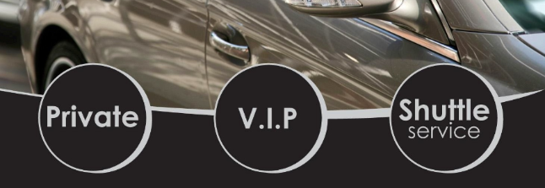](https://www.google.com/url?sa=i&rct=j&q=&esrc=s&source=images&cd=&cad=rja&uact=8&ved=0ahUKEwiX7danlfHTAhVLKyYKHdXpBk0QjRwIBw&url=http://www.miami-limo.com/art-basel-vip-car-service/&psig=AFQjCNEwlnD_yFRR8lB60GtWEebWXBjUuQ&ust=1494911402945526)

Handling security at a large, entertainment-oriented event is one of our strongest assets. From the top music events to the world of fashion, we can handle them all with the utmost professionalism, expertise and courteousness. Please feel free to call a RazorClean Security Services today to discuss any upcoming event. We’ll be happy to thoroughly answer all of your questions and propose a security program perfectly suited for your event.

One thing our clientele has grown to realize is that regardless of the magnitude of the event, we’re always on the ball. RazorClean Security Services is reputable for its comprehensive services and ability to custom craft security plans with one or multiple offerings. These include:

Corporate and private investigation

Cyber Security

Fraud prevention and detection (corporate and private)

Compliance and governance

Risk assessment

Litigation support

Crisis management

We always maintain the highest standards of quality control and security practices. Internally, we are licensed to provide training to staff members, who are all certified by the Division of Criminal Justice, bonded and insured.

For a discrete, complimentary consultation, contact one of our specialists at RazorClean Security Services at 1-855-GO RZCLN (467-9256) or Signup@rzclnsecurityservices.com